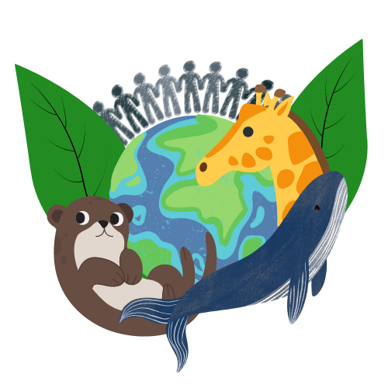

**W**ORLD**C**HANGER

**MOBILE APPLICATION DEVELOPMENT**

**MAJOR WORK DELIVERABLE 1**

**TASK ONE – STORYBOARD**

**Video URL:** [**https://echo360.net.au/media/5eb633d8-1541-4045-8e1f-ff41b2825838/public**](https://echo360.net.au/media/5eb633d8-1541-4045-8e1f-ff41b2825838/public)

**Figma URL:** [**https://www.figma.com/file/SM29MQwCR6U0WukWfrDssY/Major-Work-Deliverable-1?t=2RrzBmapaDyElfpa-1**](https://www.figma.com/file/SM29MQwCR6U0WukWfrDssY/Major-Work-Deliverable-1?t=2RrzBmapaDyElfpa-1)

**Figma – Storyboard Screen Shot**

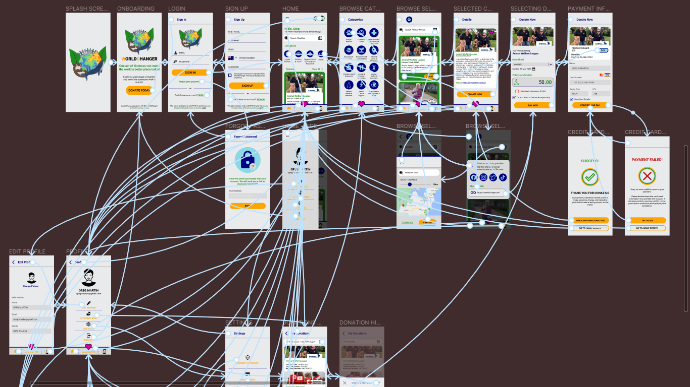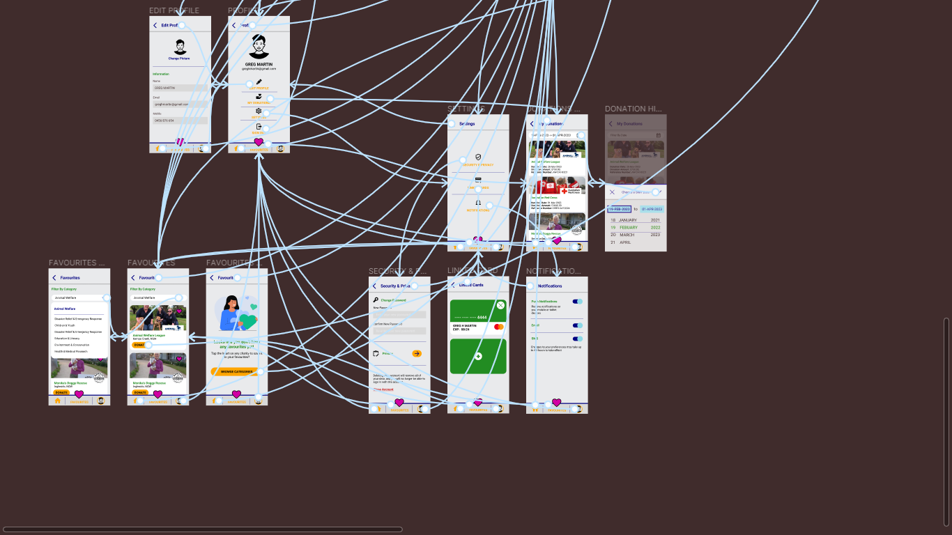

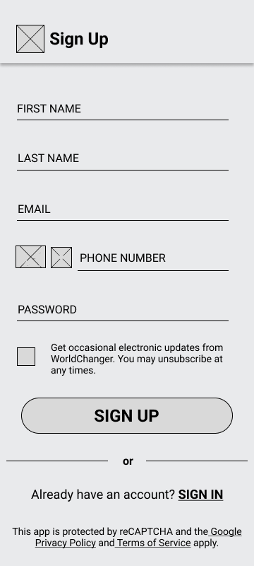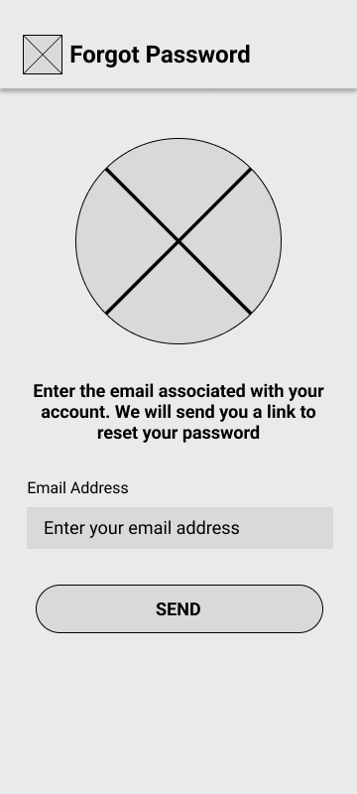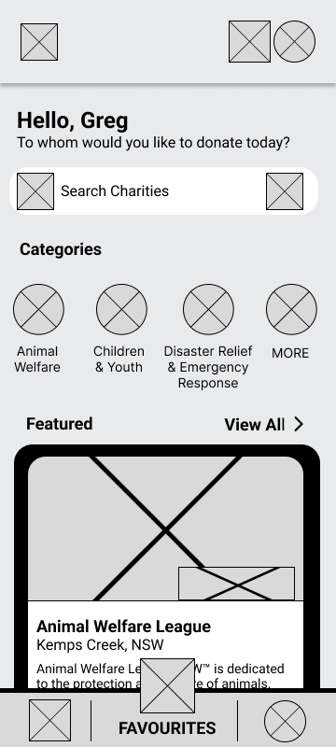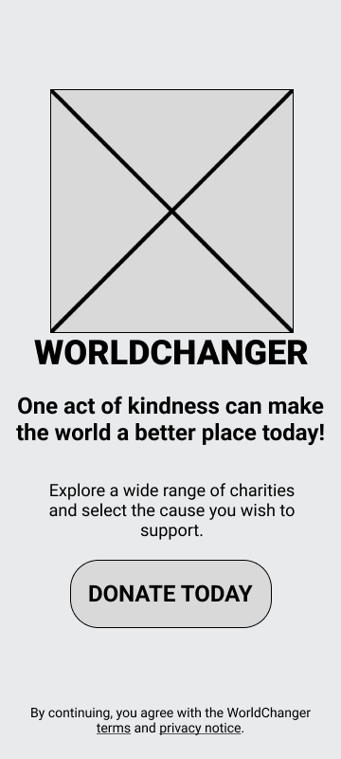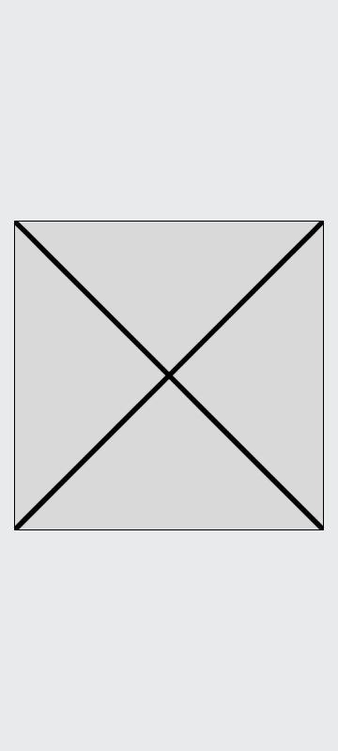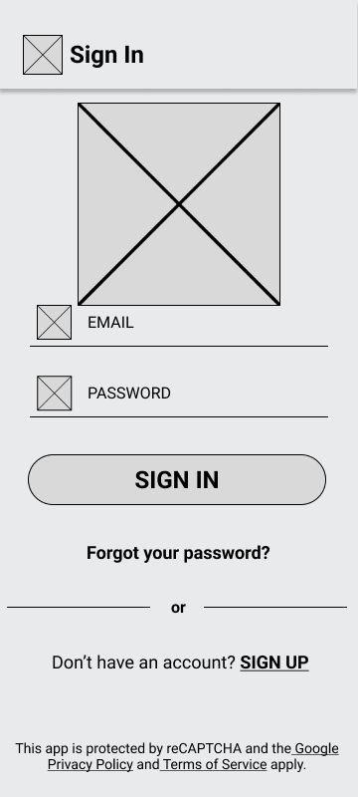**TASK 2 – WIREFRAMES**

Sign In

Onboarding

Splash

Home

Forgot Password

Sign Up

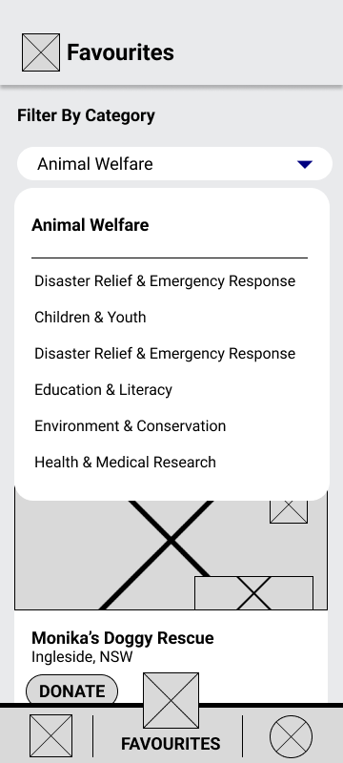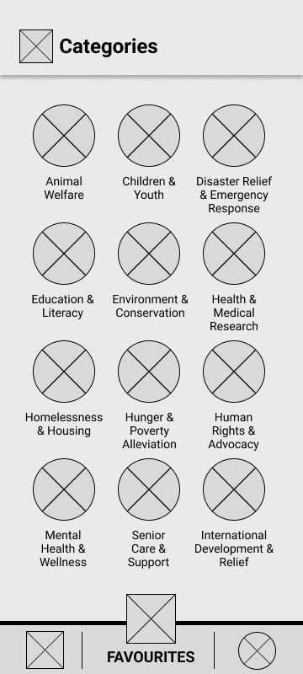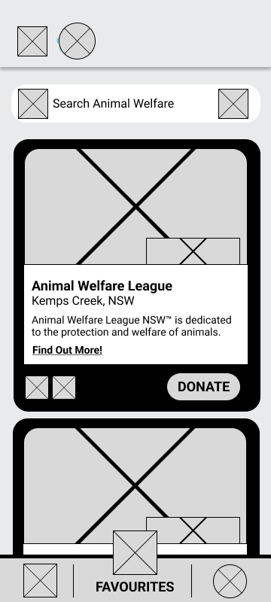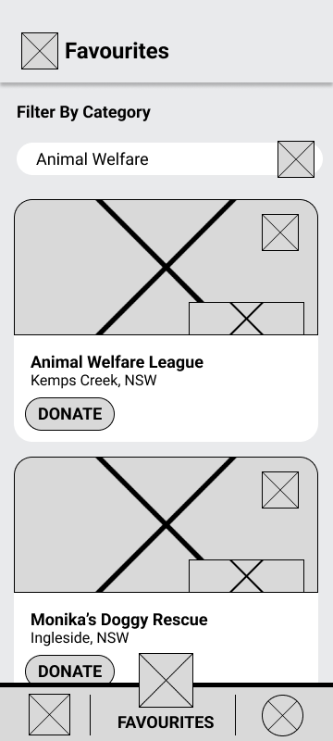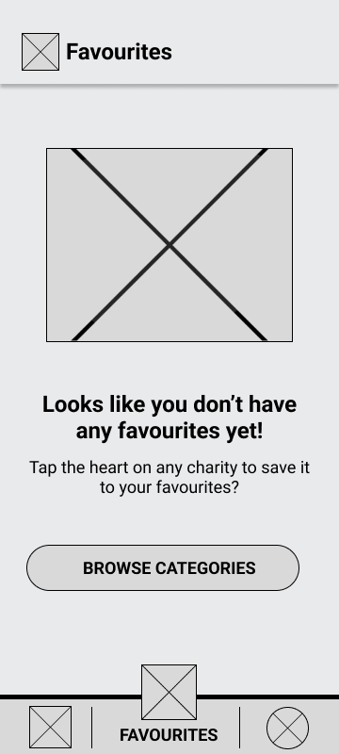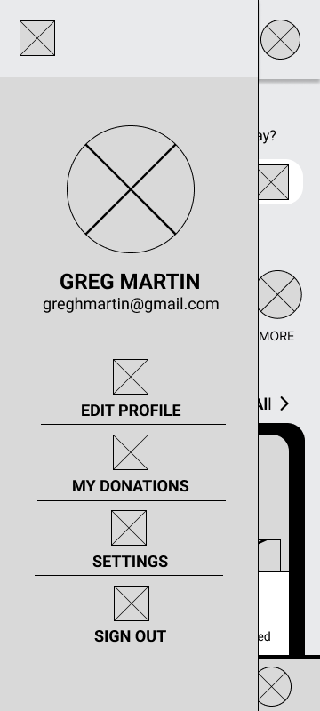

Favourites

No Favourites Selected

Favourites – Charity Category Filter

Browse Categories

Selected Category

Home - Hamburger Menu

Selected Charity Category – Location Filter

Charity Details

Credit Card Validation - Successful

Share Charity Pop Up

Enter Donation Amount

Payment Information

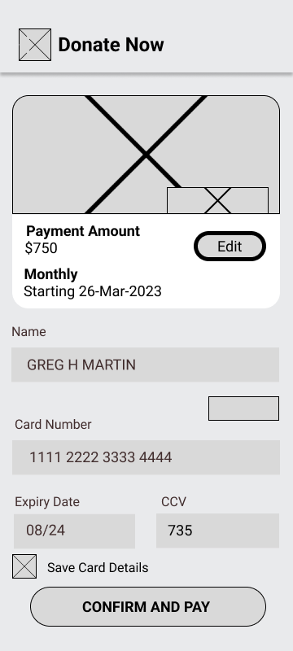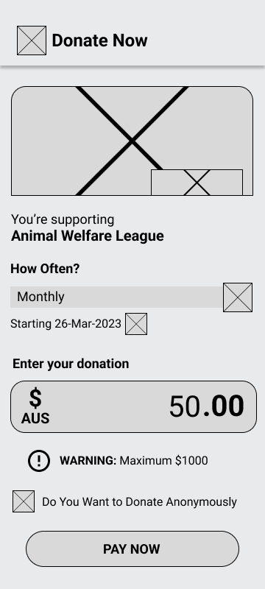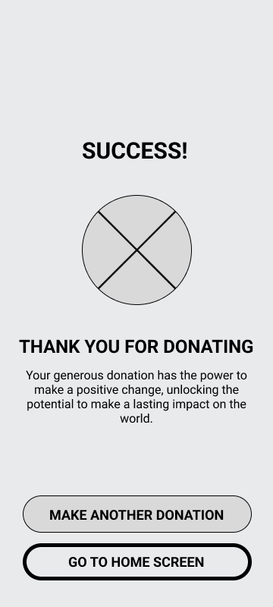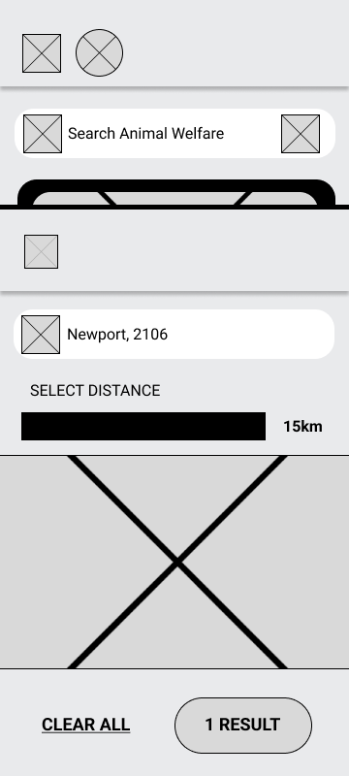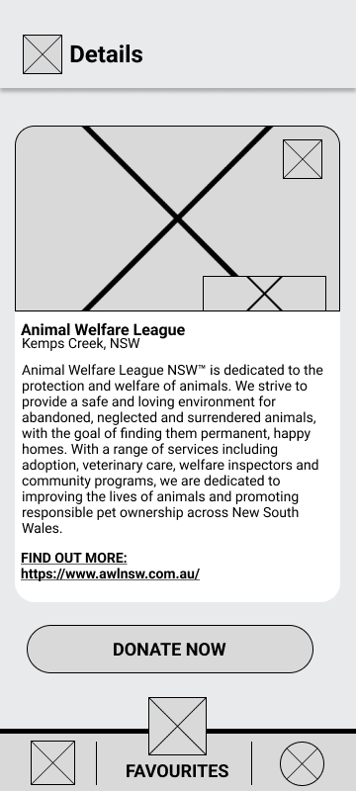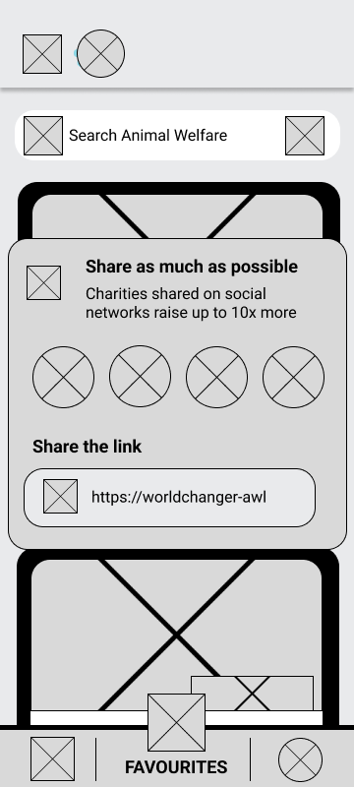

Credit Card Validation - Successful

Enter Donation Amount

Payment Information

Selected Charity Category - Location Filter

Charity Details

Share Charity Pop Up

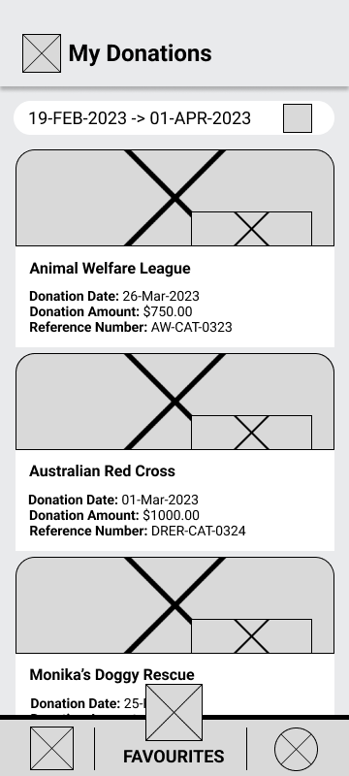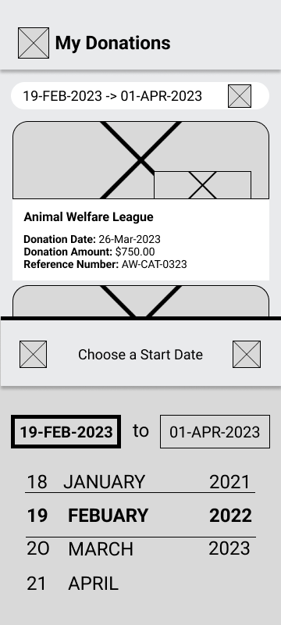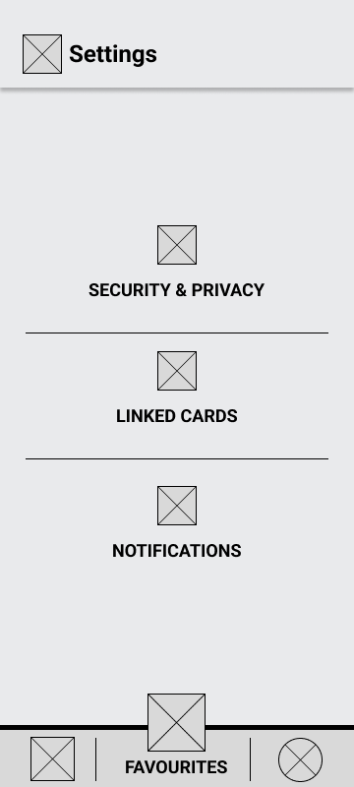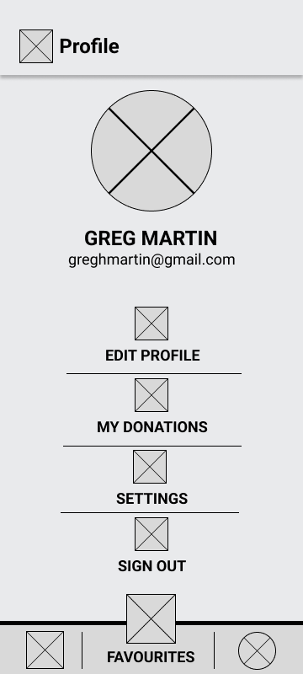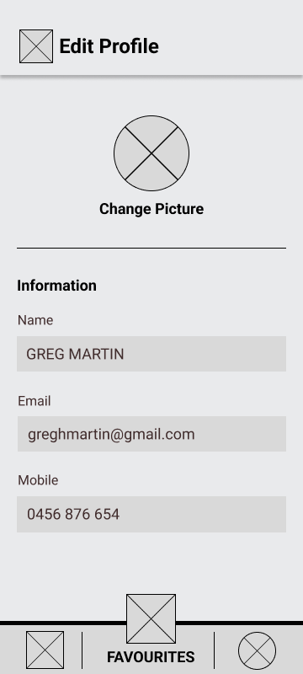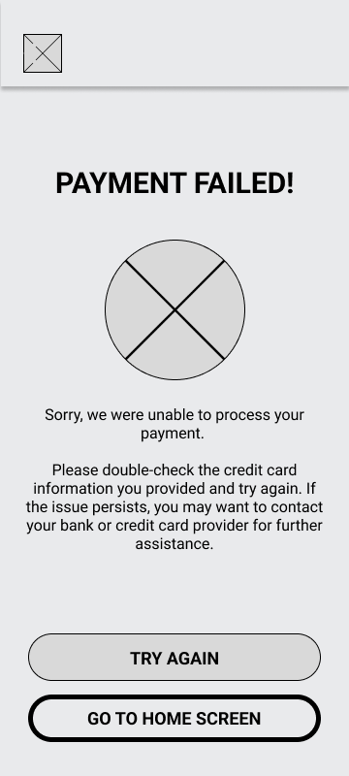

Settings

My Donations - Date Filter

My Donations

Profile

Edit Profile

Credit Card Validation - Failed

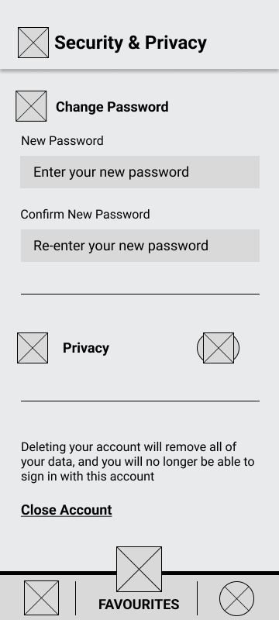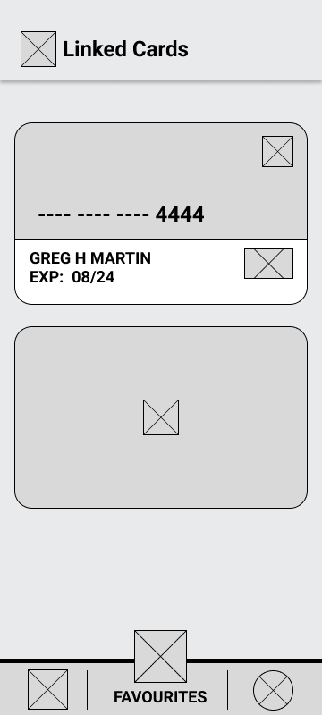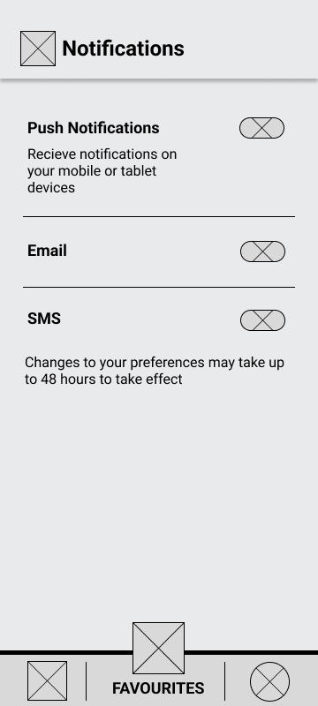

Security and Privacy

Linked Cards

Notifications

**TASK 3: MOCKUPS**

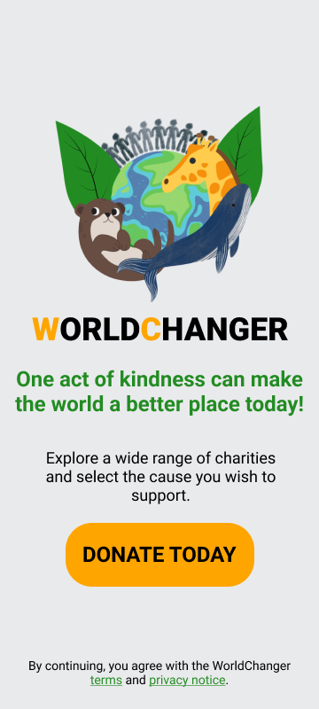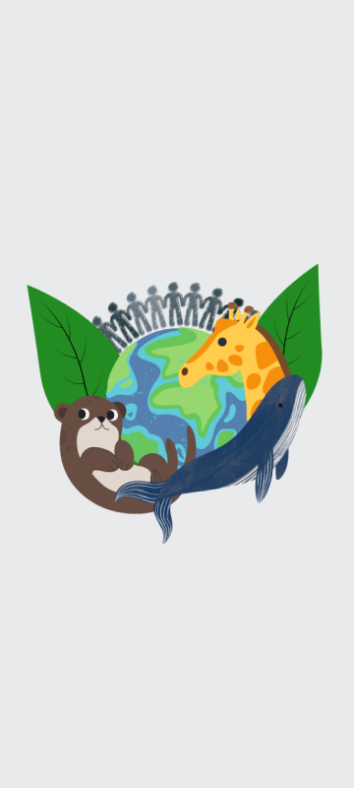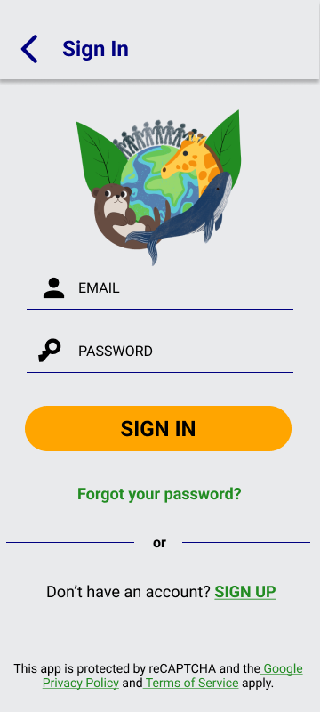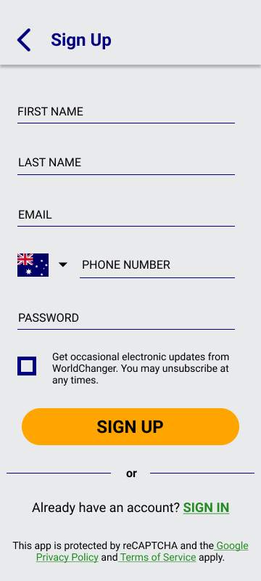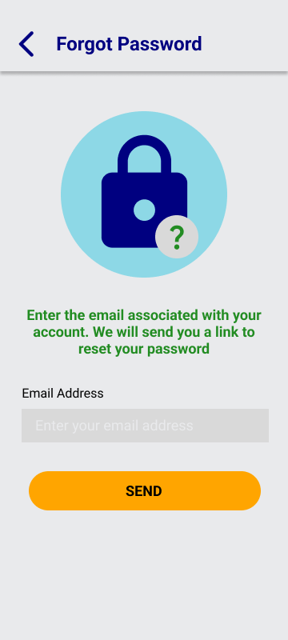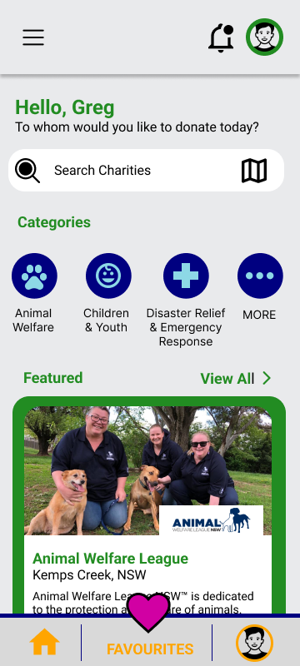

Splash

Onboarding

Sign In

Sign Up

Forgot Password

Home

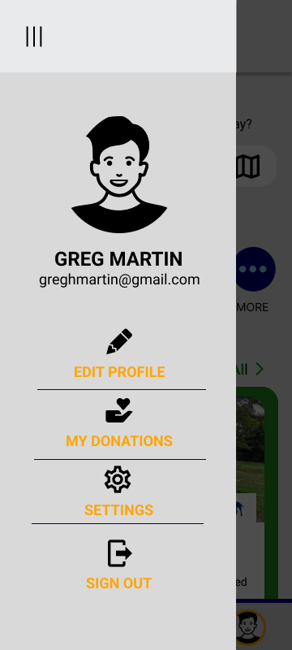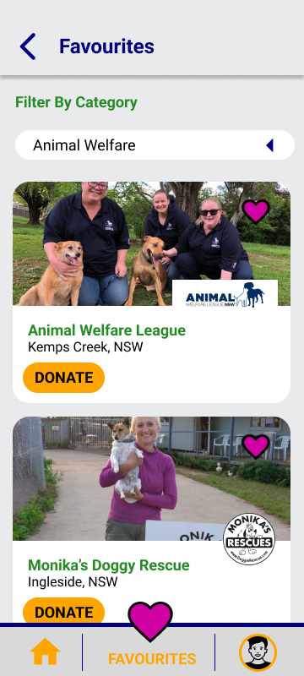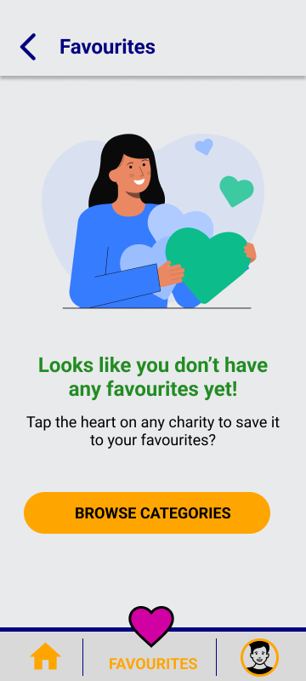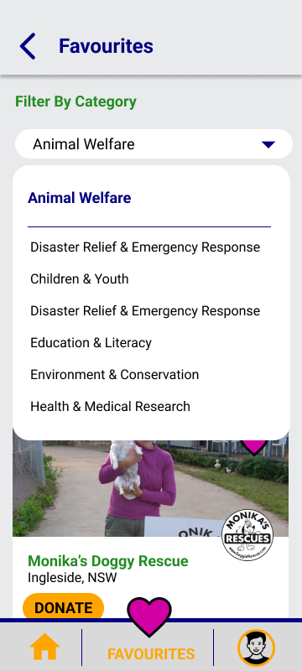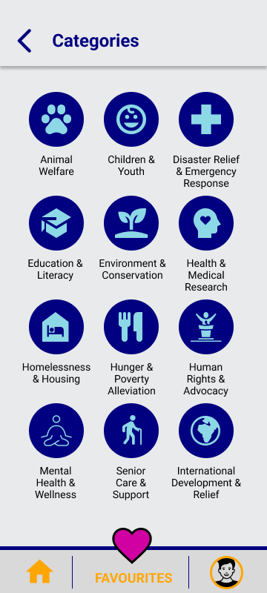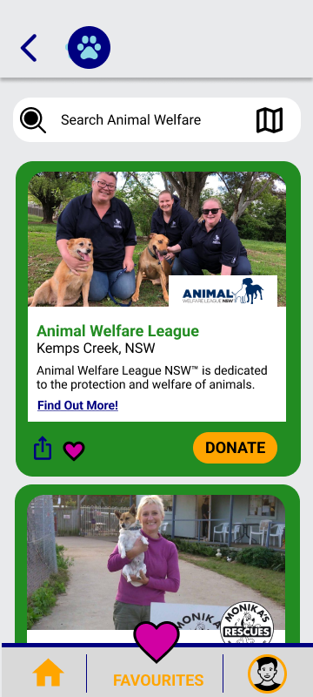

Home - Hamburger Menu

Favourites

No Favourites Selected

Favourites – Charity Category Filter

Browse Categories

Selected Category

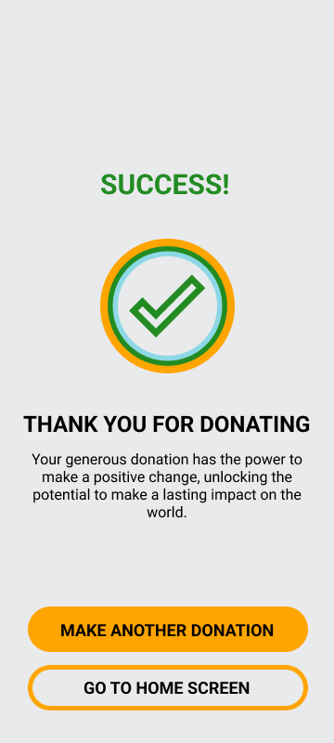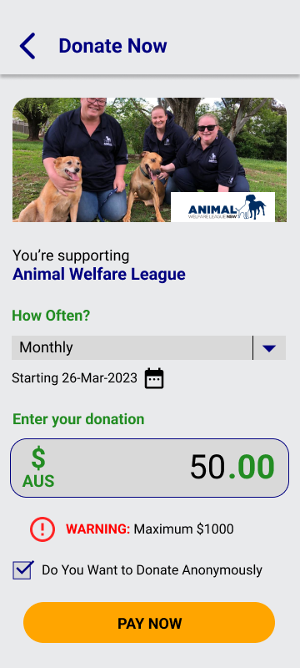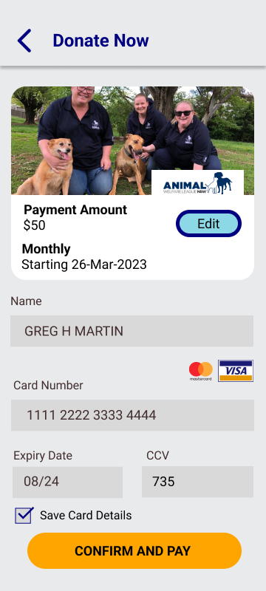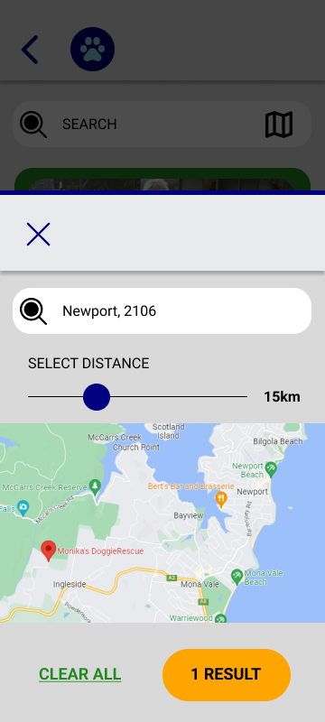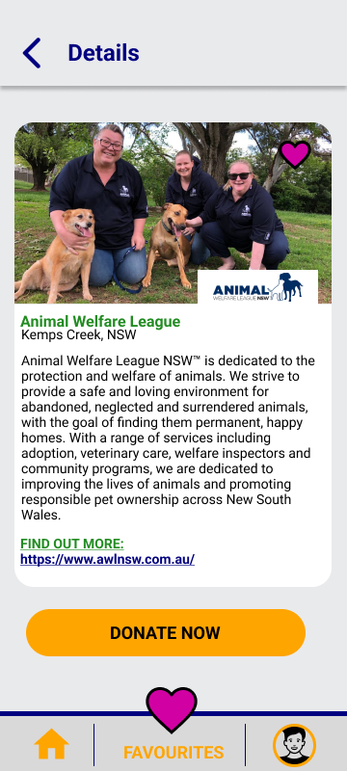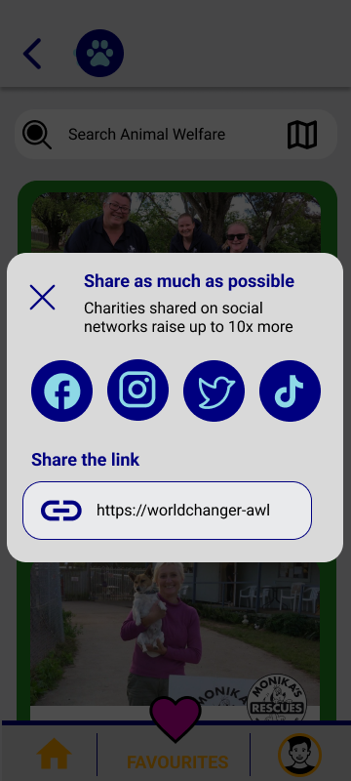

Selected Charity Category – Location Filter

Charity Details

Credit Card Validation - Successful

Share Charity Pop Up

Enter Donation Amount

Payment Information

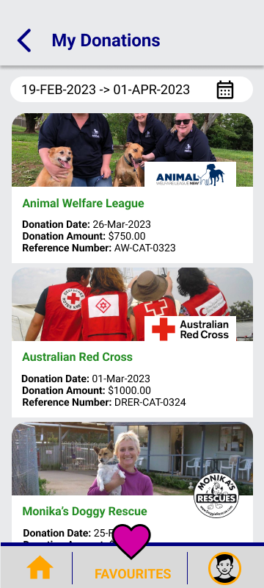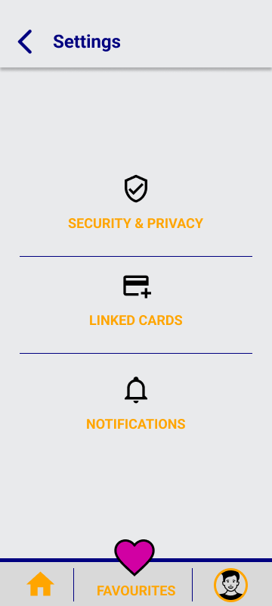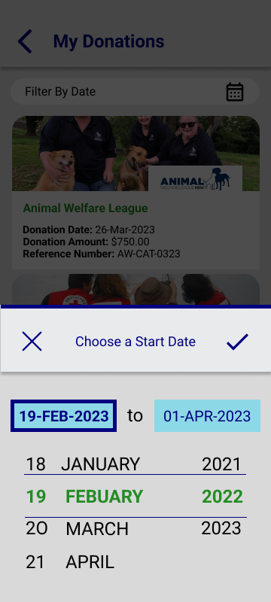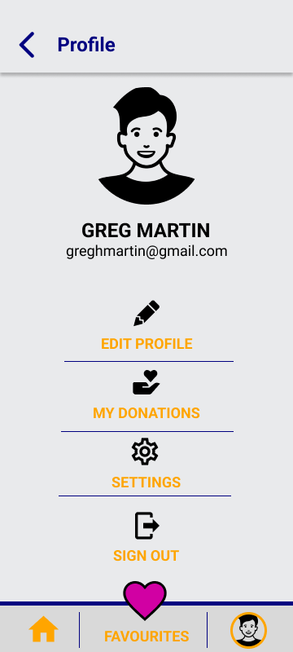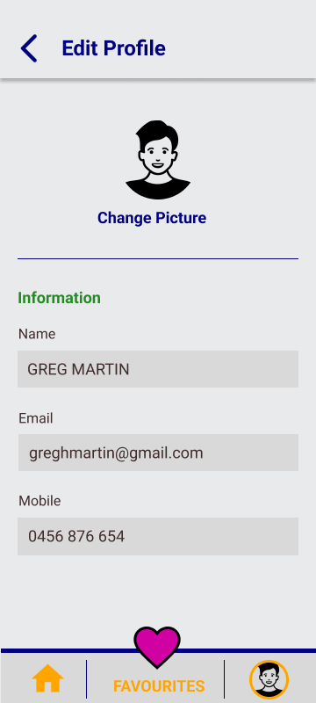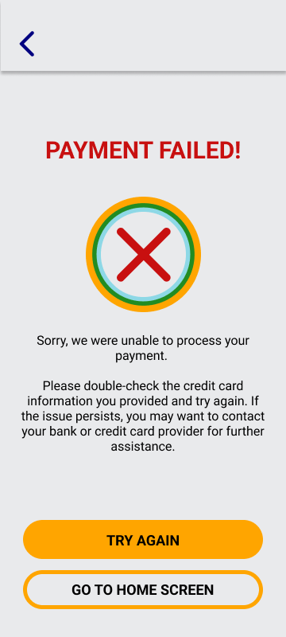

Profile

Edit Profile

My Donations

Settings

My Donations - Date Filter

Credit Card Validation - Failed

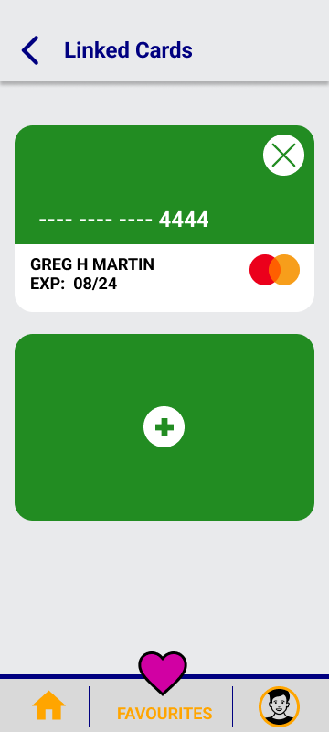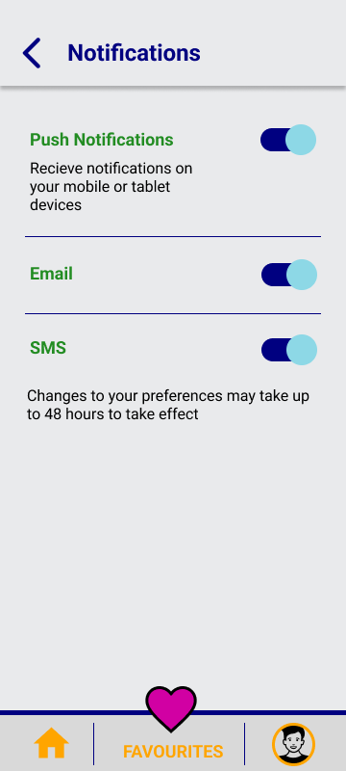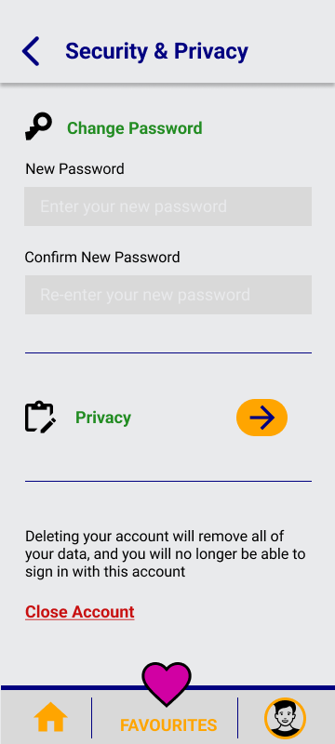

Linked Cards

Notifications

Security and Privacy

**TASK 4: BACKGROUND READING/RESEARCH**

During the development of WorldChanger, I conducted research on GoFundMe, a widely used and successful charity app, to identify the factors that make it a popular app on the market. I was amazed to discover that the app's versatility is one of its most significant features. The platform provides a space where both individuals and charities can create fundraising campaigns for a wide range of causes, from personal emergencies to community projects, global humanitarian crises, and more. This inclusivity ensures that people can donate to charities that resonate with them deeply, enabling them to make a difference in the world. This discovery inspired me to incorporate similar categories in WorldChanger to ensure that the app caters to a broad range of people and supports diverse charitable causes. By incorporating this approach, WorldChanger can become an inclusive platform that can serve a wider audience and promote greater impact and positive change. Another valuable feature of GoFundMe that I identified was its ability to simplify the donation process by enabling users to make recurring donations. This feature allows users to support their chosen charity regularly without the need to repeatedly initiate a new donation. Drawing inspiration from this, I have integrated a similar feature into WorldChanger, enabling users to set the amount and frequency of their donations. With this feature, users can leave it on autopilot and make a continuous impact on the causes they care about. By simplifying the process of making recurring donations, WorldChanger can empower users to create a sustainable impact and support their favourite charities in a hassle-free manner. Apart from its capability to offer versatile fundraising categories and set up recurring donations, GoFundMe's success can also be attributed to its feature of enabling users to share charity campaigns through social media. Therefore, I have made sure to incorporate this feature into WorldChanger, which allows users to easily share their chosen charity on various social media platforms. This feature will help raise awareness and encourage others to get involved and support the same cause. Through careful analysis and integration of the popular key features from GoFundMe, I have created a charity app that can meet the needs of users who are passionate about sharing and making a positive impact in the world.

I also followed the latest strategies outlined in the article “How to Design an App in 2022 (New Strategies) by Cameron Barrie. This article provided valuable insights into the latest trends and best practices in app design to create a seamless user experience. To begin with, I focused on the app's colour scheme. I researched successful charitable organisations and found inspiration from their unique colour schemes. UNICEF's signature blue colour scheme conveys trust and reliability, while the Australian Red Cross's bold and passionate red colour scheme evokes a sense of urgency and passion. Additionally, The Nature Conservatory Australia's green colour scheme effectively invokes a sense of environmental awareness and sustainability. I also researched colour psychology and colour theory to ensure that the colours I chose aligned with the emotions and brand identity I want to convey. After conducting this research, I deliberately chose a colour scheme for WorldChanger that would convey a message of trust, compassion, and generosity. My aim was to create a colour scheme that would resonate with our target audience and inspire users to make a significant difference in the world. I was also conscious of creating a colour scheme that is accessible to all users, including those with colour vision deficiencies. To achieve this, I followed the accessibility guidelines to ensure that the colour scheme has sufficient contrast to distinguish layered elements such as text or icons on a background, thus promoting inclusivity. This approach created an inclusive app design. Overall, I considered the selection and integration of the colour scheme to create an app design that effectively communicates WorldChanger's message and inspires users to make a positive impact in the world.

Next, I carefully selected a font that was easy to read and complimented the app's overall aesthetic. Instagram, Airbnb, and Spotify are among the popular apps that use Sans Serif typography to create a sleek look that appeals to users. I conducted a thorough analysis of various Sans Serif fonts and ultimately selected Roboto as the perfect typeface for WorldChanger. Its superior clarity, readability, and compatibility with both iOS and Android platforms made it an ideal choice. Additionally, Roboto has a diverse range of weights and styles that can help create a visual hierarchy to highlight the app's most essential elements. To ensure a user-friendly and accessible design, I meticulously adjusted the font sizes to be proportional to the images used in the app, as I noticed that all popular apps like Instagram, Airbnb, and Spotify do. I also followed their lead by carefully selecting and placing typography elements to guide users towards important information, conveying a sense of professionalism and trustworthiness. By incorporating these typography design ideas into the overall functionality and design of WorldChanger, the app promotes a sense of trust and reliability. This, in turn, encourages users to want to make a difference through charitable donations. My strategic use of typography has contributed to a visually appealing and user-friendly interface that effectively communicates the app's message, enhancing its accessibility and functionality.

In addition to typography, I paid attention to the iconography used in the app as icons are essential for navigation purposes. I took great care in selecting icons that were memorable and not overly complex, as they needed to be visually appealing and self-explanatory while not detracting from the app's content. Since mobile devices have limited screen real estate, choosing the right icons was crucial to the success of the app's design. To ensure that I chose the best icons, I researched multiple popular apps, such as Instagram, Facebook, and Twitter, which use instantly recognisable icons that enable users to navigate the app easily. These icons are designed with a minimalist approach, resulting in a clean and uncluttered user experience. I followed their approach and carefully selected and designed icons that aligned with the app's overall aesthetic, were visually appealing, and were easy to understand. By selecting and placing each icon meticulously, users can move seamlessly through the app's various features without confusion or frustration. As a result, I created a user-friendly app that provides a smooth and enjoyable experience for users by prioritising effective iconography.

Finally, I focused on the navigation and user flow of the app. I studied the navigation paradigms of popular apps such as Airbnb, Google Maps, and Spotify to understand how they effectively guide users through their app flow. One important aspect of navigation is providing clear and consistent labelling for each section or page. I ensured that each section of my app had a clear label, and the labels were consistent throughout the app. In addition to labelling, I also considered the placement of navigation elements in my app. For example, I placed the main navigation bar at the bottom of the screen, which is a common placement in many popular apps. This makes it easy for users to access the main navigation options with their thumbs, which is important for one-handed use. Furthermore, I made use of standard navigation elements, such as the hamburger menu and search bar, to guide users through the app. For example, I used a hamburger menu to provide access to less frequently used sections of the app, and a search bar to allow users to quickly find what they are looking for. To enhance the usability of my app, I implemented various filtering options to help users quickly find what they need. One of the filters I incorporated allows users to filter the nearest charities by location, which is particularly useful for users who want to support charities in their local community. Another filtering option allows users to filter charities by category, which helps users find charities that align with their interests or values. Additionally, I added the ability for users to filter through their donation receipts by date, which provides an easy way for users to track their donations and view their giving history. These filtering options provide users with more control over their app experience and make it easier for them to find the information they need. Overall, I integrated navigation into my app by studying the effective navigation paradigms of other popular apps. I accomplished this by incorporating clear labelling, appropriate placement, standard navigation elements, and intuitive gestures. This ensures that users can easily navigate through the app and have a positive user experience.

By incorporating the latest app design strategies mentioned in the article and conducting thorough background research on other popular apps, I am confident that I have created a well-designed app that delivers a seamless user experience. The app’s user-friendly and accessible design enables all users to effortlessly support the causes they care about by connecting them with reputable charities.

**REFERENCES**

Australian Red Cross. “Ways to Donate.” *Australian Red Cross*, 2023, www.redcross.org.au/donate-funds/?gclid=Cj0KCQjw8e-gBhD0ARIsAJiDsaWhVuJjvDyr1K07NF485U0IV_mCnSO8N4iPvv4waD2oNRLLQXfT8noaAsG7EALw_wcB. Accessed 24 Mar. 2023.

Barrie, Cameron. “How to Design an App in 2022 (New Strategies).” *Bilue.com.au*, 7 Dec. 2022, bilue.com.au/article/how-to-design-an-app-in-2022-new-strategies.

Boicheva, Sandra. “How to Choose the Best UI Fonts for Apps [+10 Safest Fonts] | HtmlBurger.” *HtmlBurger Blog*, 27 May 2022, htmlburger.com/blog/fonts-for-apps/. Accessed 24 Mar. 2023.

Cherry, Kendra. “Color Psychology: Does It Affect How You Feel?” *Verywell Mind*, 28 May 2020, www.verywellmind.com/color-psychology-2795824.

The Nature Conservancy Australia. “Become a Supporter of the Nature Conservancy Australia.” *The Nature Conservancy Australia*, www.natureaustralia.org.au/donate-to-our-mission/donate/become-a-supporter/?gclid=Cj0KCQjw8e-gBhD0ARIsAJiDsaX458z5sDc_Al08nepDHpOxOlDdfe7JHkT3hGELyAYQmMqUVA67sroaAjCYEALw_wcB. Accessed 24 Mar. 2023.

UNICEF. “UNICEF.” *Unicef.org*, 2022, www.unicef.org/.

W3C. “Web Content Accessibility Guidelines (WCAG) 2.0.” *W3.org*, 2019, www.w3.org/TR/WCAG20/.